Name: Ramya Reddy Baapathu

Join Synthea Sample Tables

STEP1: Pick a data warehouse environment and create a dataset for this data (include your first name in the dataset name) and load each table into the dataset.
Before we start loading data into Snowflake, the first thing we do is create a database and a schema that will act as a containing unit for the tables that will host the data in question. For this case, we created a database known as ramya_data as per the basic stipulation of the assignment that asked for the creation of a database in our own first name.
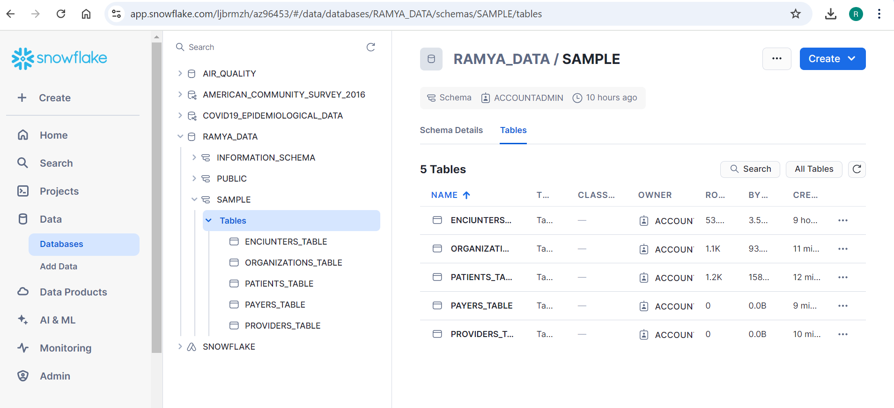

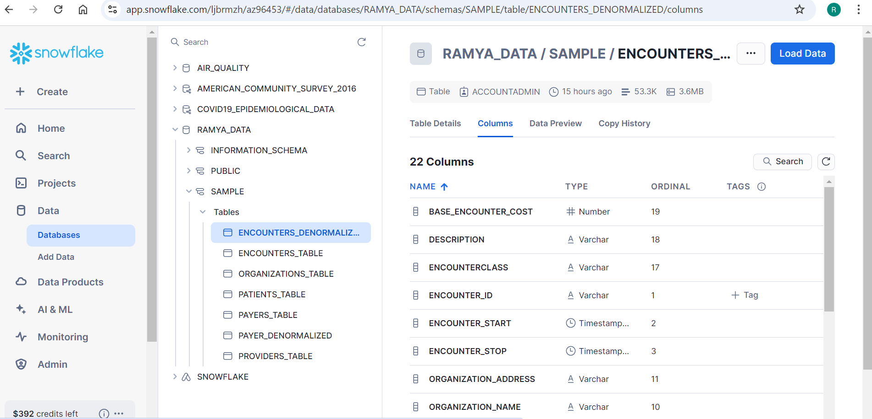
STEP 2: Start with the encounters table and create a denormalized version that includes full patient information, organization information, provider information, and payer information for each encounter in a single table.
The query used to do denormalization of encounters_table is CREATE TABLE encounters_denormalized AS
SELECT
e.Id AS encounter_id,
e.REASONDESCRIPTION,
p.Id AS patient_id,
p.Name AS patient_name,
p.Birthdate AS patient_birthdate,
org.Id AS organization_id,
org.Name AS organization_name,
prov.Id AS provider_id,
prov.Name AS provider_name,
pay.Id AS payer_id,
pay.Name AS payer_name,
e.TOTAL_CLAIM_COST,
e.ENCOUNTERCLASS,
e.BASE_ENCOUNTER_COST
FROM
encounters e
JOIN patients p ON e.PATIENT = p.Id
JOIN organizations org ON e.ORGANIZATION = org.Id
JOIN providers prov ON e.PROVIDER = prov.Id
JOIN payers pay ON e.PAYER = pay.Id;

In data modeling, the step that I am doing here is to define the structure of the data. Every table in Snowflake is similar to an entity in our data set, including patients, encounters, organizations, providers, and payers. Snowflake has structured tables where an individual must specify the format in which the data will be displayed in a particular cell. For instance, in the encounters table, there is a field such as Id, REASONDESCRIPTION, and TOTAL_CLAIM_COST. The schema specifies a certain data type of the column, for example, STRING for a text field or NUMBER for a numerical field. After creating the tables, however, the next step is to populate these tables with data. Snowflake enables you to load data (most frequently in CSV format) to a stage area and then load the data into the corresponding tables using the COPY INTO command. Snowflake’s capability to process massive structured data, therefore, makes it suitable for archiving and querying healthcare data, including patient encounters and payer transitions.
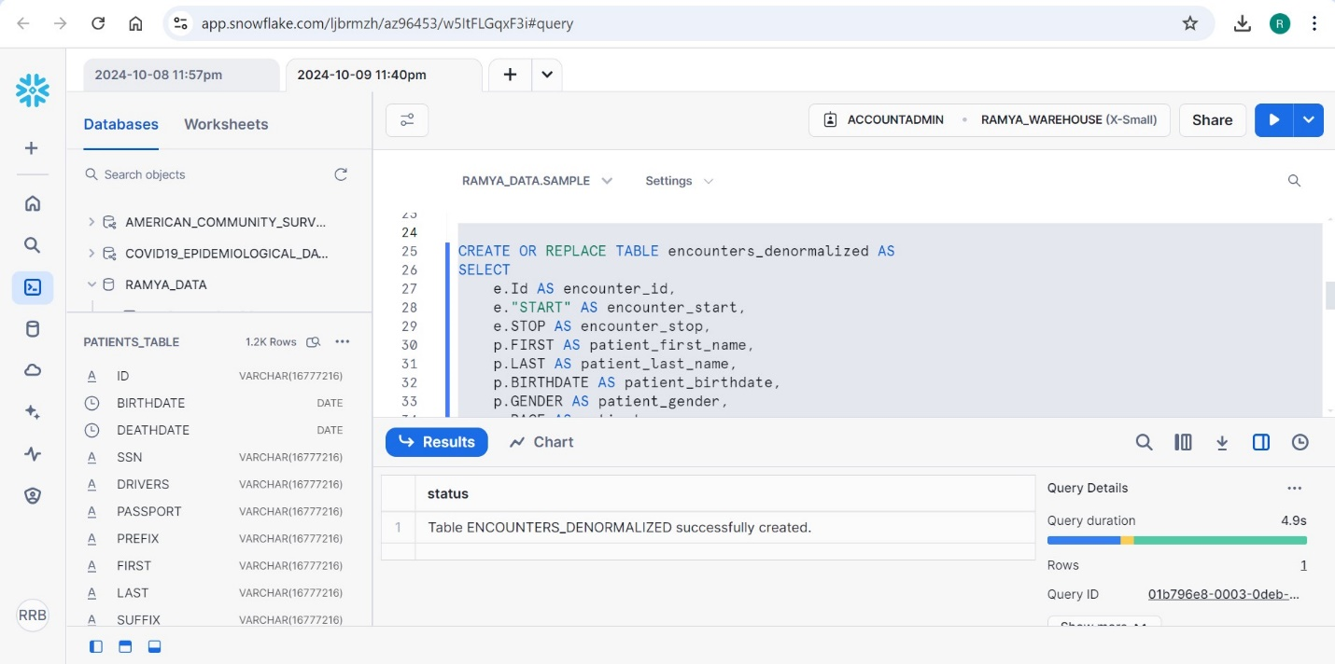
Table ENCOUNTERS_DENORMALIZED IS CREATED.

De-normalizing the Encounters Table Denormalization is the process of adding more than a single field name to make those tables in a database that is least complex for retrieval of related data. In Snowflake, this is done by using SQL JOIN operations where we have some information residing in multiple tables and need to present in one. In this step, the idea is to join the encounters with patients, organizations, providers, and payers. These tables involve different categories of data concerning an encounter that includes the identity of the patient involved, the organization that delivered the service, the healthcare provider, and the payer. The SQL statement that is used contains several times the JOIN keyword, and each of its occurrences connects one table. For instance, patients are joined by a field known as PPATIENT, which connects the encounter to a specific patient. The upshot of this computation is the creation of a new table, called payers_denormalized, that contains all the information needed about an encounter in an aggregated format. This table helps in any further queries to be made easier because the information being sought after is in one table rather than the information being split into several tables. Such join operations are mostly optimized in Snowflake, especially for the large datasets, which makes the tool the best for the denormalization of the data in larger datasets.

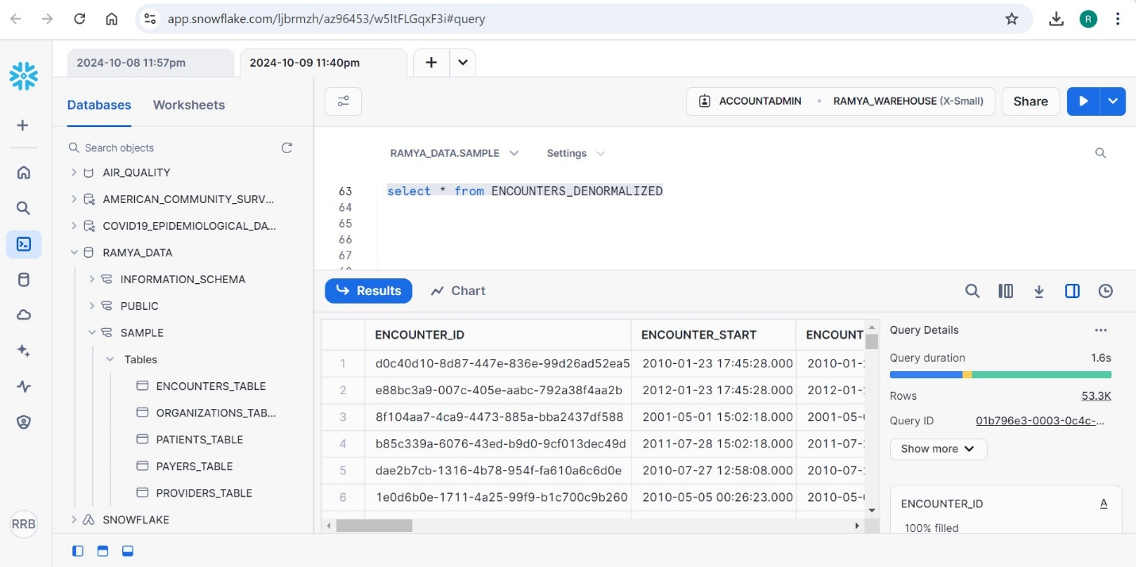
FROM THE ABOVE PICTURE WE CAN SAY THAT, THIS IS THE DATA WHICH IS RETRIVED FROM AFTER DOING DENORMALIZATION OF DATA ENCOUNTERS.

STEP 3: Start with the payer transitions table and create a denormalized version that includes full patient information and payer information.
CREATE TABLE payer_transitions_denormalized AS
SELECT
pt.Id AS payer_transition_id,
p.Id AS patient_id,
p.Name AS patient_name,
p.Birthdate AS patient_birthdate,
pay.Id AS payer_id,
pay.Name AS payer_name,
pt.START_DATE,
pt.END_DATE
FROM
payer_transitions pt
JOIN patients p ON pt.PATIENT = p.Id
JOIN payers pay ON pt.PAYER = pay.Id;
Like the encounters table, the payer transition table is denormalized because it contains both patient and payer data. This table has information on the transfers between different payer classifications by patients. In this step, vertex name and payer transitions are joined with the patients and payers table through an SQL query. This ensures that the final denormalized table, payer_transitions_denormalized, has all necessary patient information (for example, name and birthdate) as well as payer data (for instance, name and time the payer was valid for the patient). This denormalization makes it easier to explain patient flow and how it impacts cost and/or outcome among different payers. The query engine of Snowflake qualifies in such a way that even compound joins on large tables are optimized, and that is so crucial under large-scale healthcare data.
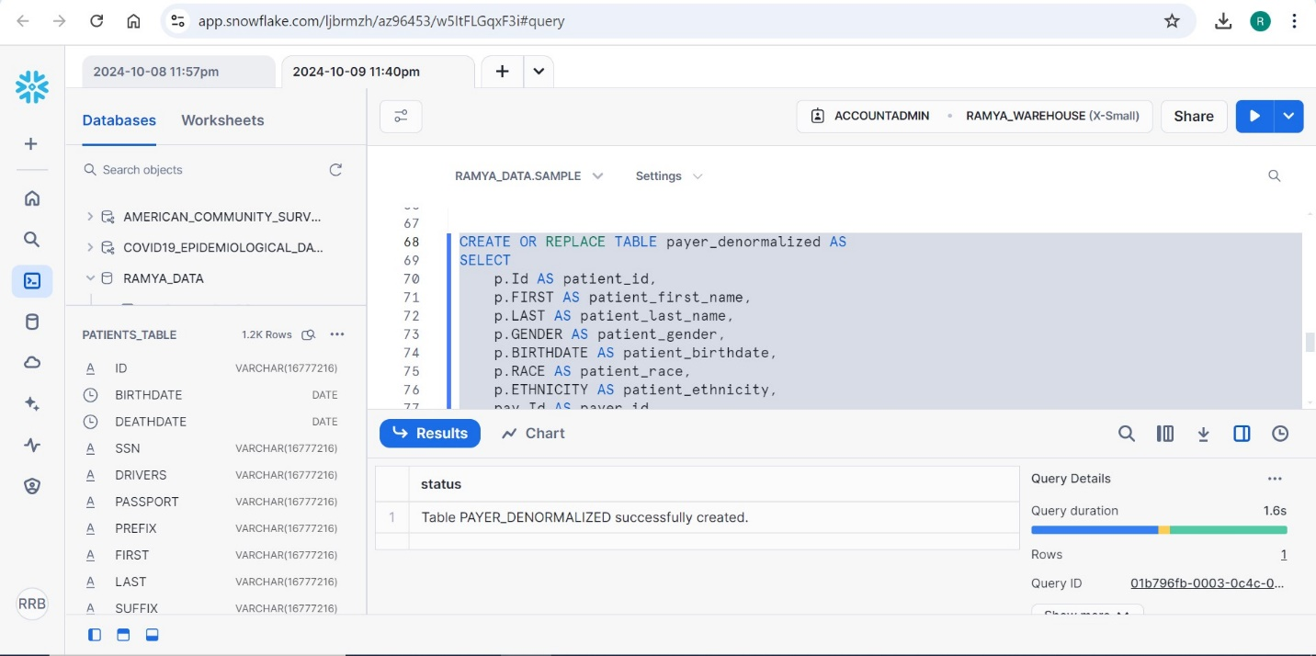

Once the tables are denormalized, the next step is to perform SQL queries to extract meaningful insights from the data. The denormalized structure makes it easier to run queries that span multiple dimensions of the data (patient, provider, organization, payer, etc.).

STEP 4: Research Questions Using SQL
Here are some examples of research questions and the corresponding SQL queries that you can use to analyze the denormalized data:
1) What are the most common reasons for patient encounters?
SELECT
REASONDESCRIPTION,
COUNT(*) AS encounter_count
FROM
encounters_denormalized
GROUP BY
REASONDESCRIPTION
ORDER BY
encounter_count DESC
LIMIT 10;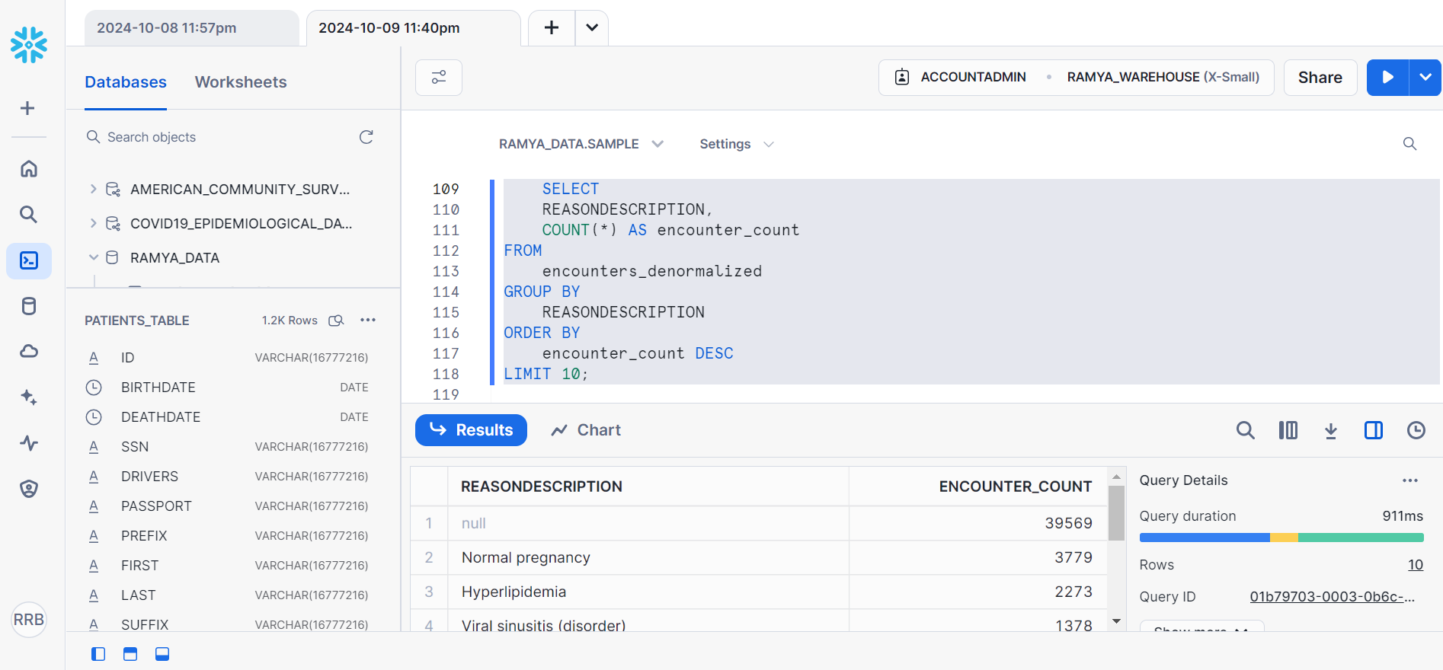
This query enables one to know which diseases are mostly leading patients to their healthcare service providers. When the encounters are arranged according to the reason for the visit (REASONDESCRIPTION), it entails how many times each of the reasons occurs. Organized by the number of patients’s visits, the results show the most common reasons for patient visits. This information is very important when planning and organizing the facilities of the healthcare facility to increase the effectiveness of being able to treat the most frequent health conditions.

2) Which providers handle the highest number of encounters?
SELECT
provider_name,
COUNT(*) AS total_encounters
FROM
encounters_denormalized
GROUP BY
provider_name
ORDER BY
total_encounters DESC
LIMIT 5;
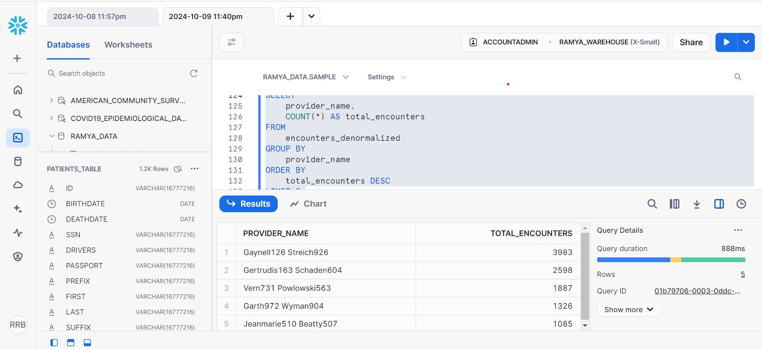
This query describes which healthcare providers (provider_name) pay most attention to the patients. Ranking the providers using the number of separate patients treated and ordering them in a descending order will show the busiest providers. This insight can be useful in checking provider metrics on their efficiency as well as the distribution of workload and perhaps to see if there is justification for hiring more members in certain specialties in healthcare organizations.

3) What is the distribution of encounter costs across different payers?
SELECT
payer_name,
AVG(TOTAL_CLAIM_COST) AS average_claim_cost,
SUM(TOTAL_CLAIM_COST) AS total_claim_cost
FROM
encounters_denormalized
GROUP BY
payer_name
ORDER BY
total_claim_cost DESC;

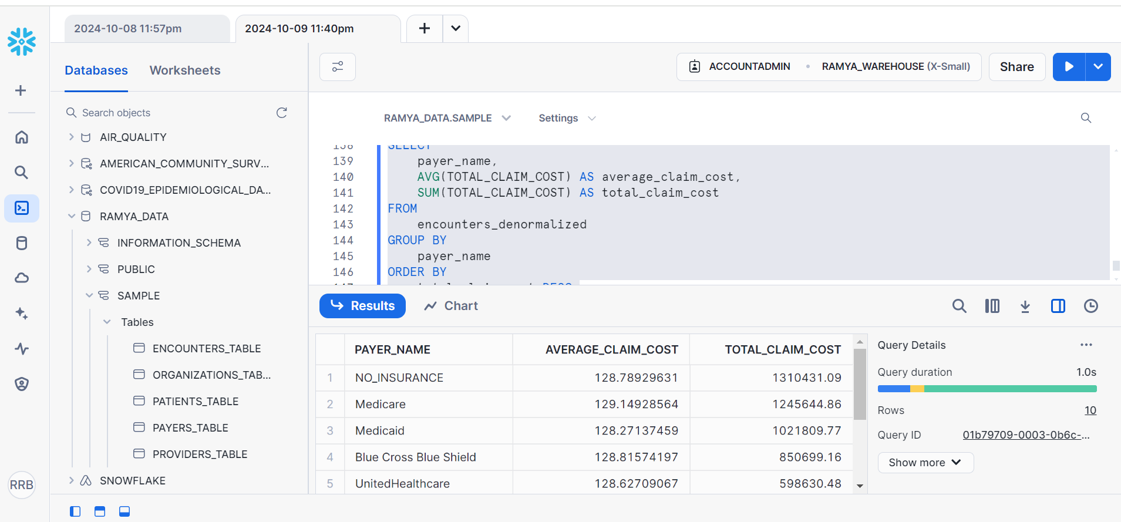
Specifically, the goal of this query is to examine the cost relationship between various payer types (payer_name) and costs. It analyzes the average and total claim cost in relation to payer that has involved the data sorting in this specific category. The sorting of the data by the total claim cost helps understand which payers are responsible for major shares of the flow; the average claim cost gives an understanding of what costs per encounter in terms of the payer.

4) What is the average age of patients for different encounter types?
SELECT
ENCOUNTERCLASS,
AVG(DATEDIFF(year, patient_birthdate, CURRENT_DATE())) AS average_age
FROM
encounters_denormalized
GROUP BY
ENCOUNTERCLASS
ORDER BY
average_age DESC;
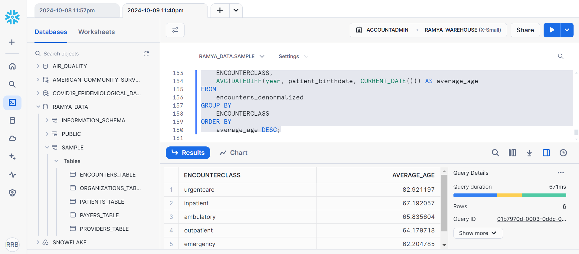
This query seeks to find a statistical average of the age of patients by different encounter classes (ENCOUNTERCLASS). By subtracting a patient’s birthdate from today and averaging this for each encounter class, the query gives information on potential trends in the age of health care encounters. Such data may be used to enhance the delivery of services based on age or estimate which encounter types are frequent among the various age groups.

5) Impact of Organization on Encounter Costs?
SELECT org.NAME AS organization_name,
AVG(e.BASE_ENCOUNTER_COST) AS average_encounter_cost,
COUNT(e.Id) AS total_encounters
FROM encounters_table e
JOIN organizations_table org ON e.ORGANIZATION = org.Id
GROUP BY org.NAME -- Group by organization name
ORDER BY average_encounter_cost DESC;

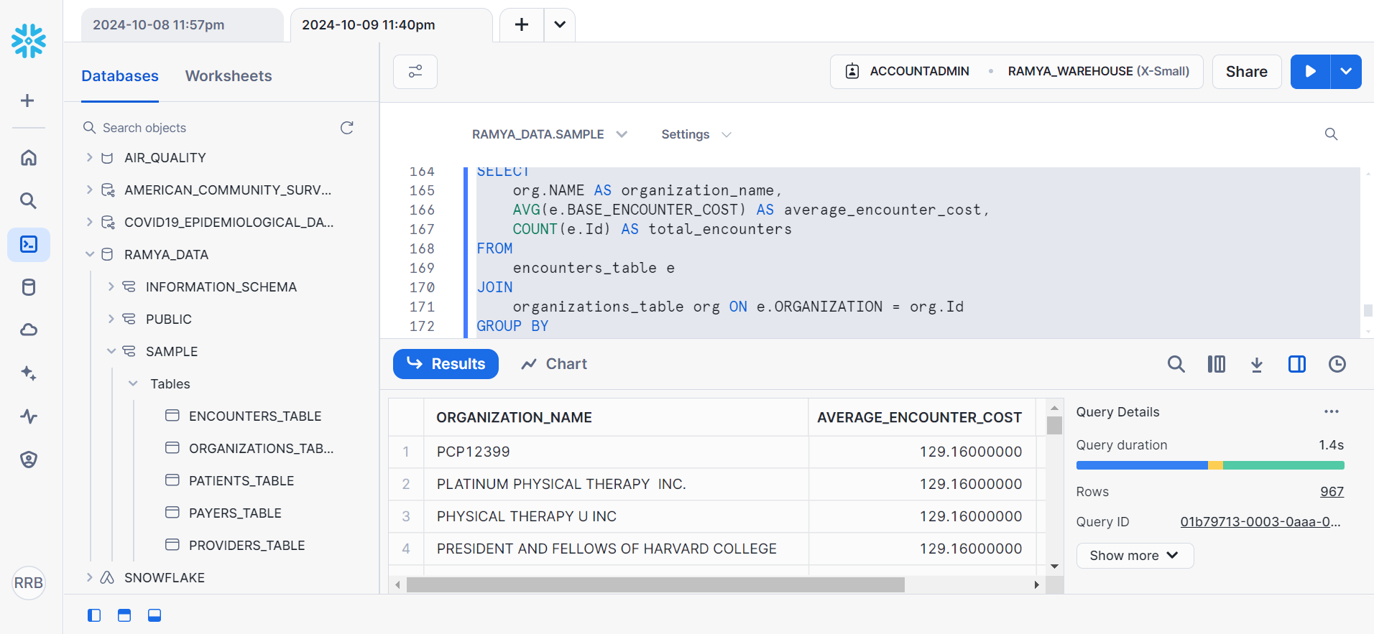
This query looks at how varied healthcare organizations (organization_name) have affected the average cost of encounters. Using this formula, it arrives at the mean base encounter cost for each organization by sorting the data in the name of the organization and giving the total number of encounters dealt with. The query shows the relation between average cost and average service volume, thereby pointing to organizations with higher and lower average costs, thereby helping in cost control and other financial analysis.

CITATIONS: https://synthetichealth.github.io/synthea/#:~:text=Use%20the%20buttons%20to%20the%20left%20to%20downloadLinks to an external site.
- Used snowflake for this assignment.

